NYC Taxi Project
By Kavita Tamire
Architectural Design:
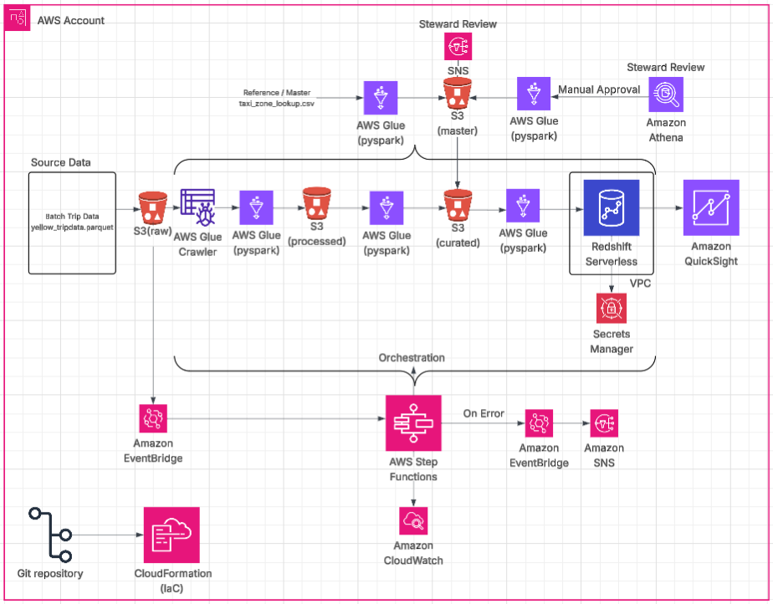

Master Data Management (MDM):
In this project, MDM is the process used to ensure that the ‘reference data’ is accurate, consistent, and controlled.
- Lookup data: taxi_zone_lookup.csv is the lookup data for zones and then we defined the list of vendors and ratecodes (manually in this case).
- LookupToMaster Glue Job: Takes lookup data as input to build the Master data i.e. single source of truth for dimensions - zones, vendors and ratecodes.
- Steward Review: For vendors data, if the confidence is between 80 and 95, we try to alert the steward through SNS for review before they are used to enrich the curated data or loaded into Redshift and approve it in Athena manually. The steward then manually triggers the ‘Steward Review’ Glue Job for simplicity of this project.
- Master Hub: The S3 master bucket acts as the "Golden Record" store in our project.

S3 Data Lakehouse Architecture:
- Raw Bucket: The landing zone for incoming source files which are Parquet in format in this project.
- Glue Crawler: The landing file is crawled over by Glue and metadata table is created in the Glue Catalog which can be used to query the data using Athena.
- RawToProcessed Glue PySpark Job : The raw data is standardized, validated and go through Data Quality rules before pushed to Processed Bucket. If DQ failes, the data is pushed to quarantine folder in the raw bucket. Either way, we integrated with Athena to query data.
- Processed Bucket: The validated/processed data is placed in this bucket after passing through DQ rules.
- ProcessedToCurated Glue PySpark Job: The data from processed(fact) and master(dimensions) buckets is joined and some transformations are applied to have the trip_details, daily_metrics, location_performance and vendor_performance in detail which are also integrated with Athena for querying.
- Curated Bucket: The final data in the form of tables required for analytical processes is now ready in this bucket.
- CuratedToRedshift Glue PySpark Job: The tables required for analytical processes are created on redshift through this job and the data is copied from curated bucket.

SCD Type 2 (Slowly Changing Dimensions):
SCD Type 2 is used to manage how the dimensional data, in this case zones, vendors and ratecodes changes over time. Instead of overwriting a zone's name or borough (which would destroy historical context), we track the history of that zone, vendor or ratecode.
- If a "Service Zone" for a specific LocationID is updated (e.g., from "Yellow Zone" to "Green Zone"), SCD Type 2 allows us to keep the old record and create a new one.
- Since YAML uses datalake-formats: delta, we implement this using the MERGE operation in your Glue Spark jobs.
- Key Columns:
  - version: To identify versions of the data.
  - effective_from and effective_to: To show when a specific version was active.
  - is_current_flag: A boolean (True/False) to find the latest version.
Data Warehouse
Redshift Serverless is used as the data warehouse having the data ready for analytics downstream.
Analytical Reporting
Quick Suite is used to generate analytics based on the data in Redshift.
Event Driven Architecture
- The landing file in S3 raw bucket triggers an EventBridge rule which in turn triggers the Step Function for this project.
- Any step failure in the State Machine would trigger the SNS topic which sends email to the Data team.
Monitoring & Governance
- Step Function failure would create a CloudWatch Alarm and send mail to data team.
- Step Function failures & Success is monitored through CloudWatch dashboard.
Infrastructure As Code
Cloud Formation with YAML template is used to create the whole infrastructure on AWS required for this project.
Version Control
Git is used as the version control for this project and the code is directly pushed to the AWS through Github Actions.
Git link : https://github.com/tkavi/nyc-taxi
Improvizations(can be added)
- Setting up event-driven Lambda for master pipeline.
- Implementing Denial flow after Steward Review.
- DQ for processing to curated data.
- Better QuickSight Analytics Dashboard.

